1.**Introduction**

1.1 **Purpose**:

The purpose of this document is to build a Result Processing system to manage the Result,Students and courses of the department to ease the Faculty Members.

1.2 **Document Conventions:**

DB Database

ERD Entity Relationship Diagram

1.3 **Intended audience and reading suggestions:**

This project is developed for manage result system.This project is useful for the Faculty Member of the Department.This project has been implemented under the guidance of Honourable Unversity Lecturer.

1.4 **Project Scope:**

Result Processing System is based on the Web Application.The system is based on relational database with its Result Processing functions.All the result of each and every courses of the students are managed through this user friendly system.

1.5 **References:**

* www.tutorialspoint.com
* www.geekforgeeks.com
* Database system concepts by Silberschatz,Korth and Sudarshan
* https://krazytech.com/projects

**2 Overall description**

**2.1 Product perspective:**

A Result Processing database System stores the following information:

* Admin(Head of the Dept.) Details: It includes Name,Mobile Number,Email ,Designation,Password of the Admin.
* User(Faculty Members) details: It includes the Name , Mobile Number, Email, Designation, Password of the Faculty Members.
* Student Details: It includes the Name,Registration Number,Mobile Number,Email,CGPA of the Students.
* Course Details:It includes Course Title,Course Code,Course Credit of the Courses.

2.2 **Product features:**

The major features of pharmacy database system as shown in below ER model: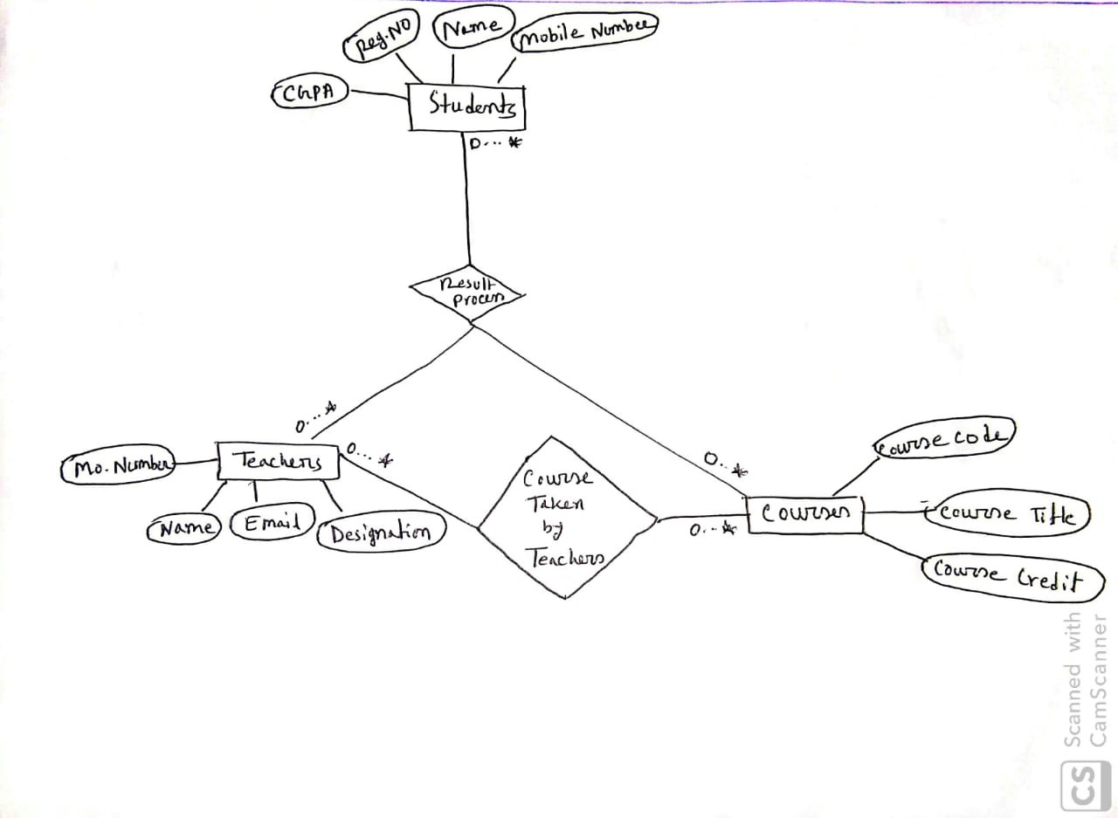

2.3 **User classes and characteristics:**

There are two types of user in Result Processing System.Admin and User.

* Admin:
* Manage User.
* Manage Courses.
* Manage Results of the Course Taken.
* Manage Students.
* Manager:
* Manage Results of the Course Taken.
* Manage Students.

2.4 **Operating Environment:**

* Database: MySQL
* Operating system: Windows or Linux
* Platform: Web browser

2.5 **Design and implementation constraint:**

1. Design user interface using front-end technologies such as HTML,CSS,Bootstrap and JavaScript.

2.Design database(ERD)

3.Implement required functionality using PHP.

2.6 **Assumption and dependencies:**

In this application ,there are a lot of dependencies.To create the Result Processing System,We will need to have the Student details,Course details on the system.Without these the Result information is incomplete.

3 **System features**

**3.1 Functional requirements:**

* Manage user
* Add new Faculty Member as User.
* View,update and delete User information
* Manage Student
* Add Student details.
* View ,update and delete Student.
* Manage Courses
* Add Courses details.
* View,update and delete Courses.
* Manage Result
* Add Attendance(Based on 10), Tutorial(10),Assignment(10),Mid Term(30),Final(40),Letter Grade of the Particular Student.
* View ,update and delete Result.

4 **External Interface Requirements**

**4.1 User interfaces:**

Front-end:HTML,CSS,Bootstrap,JavaScript.

Back-end:PHP

Tools:XAMPP,Brackets,Notepad++.

4.2 **Hardware Interfaces:**

* Computer
* A web browser which support HTML5,CSS3 & JavaScript.
* Printer

4.3 **Software Interfaces:**

* Operating system: Windows operating system for its best support and user friendliness.
* A Modern Web Browser

4.4 **Communication interfaces:**

This project supports all types of Web Browsers but should be updated.

5 **Non-functional requirements**

5.1 **Performance Requirements:**

E-R Diagram constitutes a technique for representing the logical structure of a database in a pictorial manner. This analysis is then used to organize data as a relation, normalizing relation and finally obtaining a relational database. Design ERD use online tools such creatly.com, lucidchart.com etc. Normalization is a database design technique which organizes tables in a manner that reduces redundancy and dependency of data. Here we have normalized up to 3NF.

5.2 **Safety Requirements :**

If there is any damages or disk crash, the recovery method restores a recent past copy of the database that was backed up to cloud storage.

5.3 **Security Requirements:**

Security Systems need database storage just like many other applications. However, the special requirements of the security market mean that vendors must choose their database partner carefully. Every single page is protected, without login nobody can not view or manage web page, excluding public user interface.

5.4 **Software Quality Attributes:**

**AVAILABILITY**: The available Result should be show to Admin(Head of Dept.) and User(Faculty Members) in current time. Available Student details,Course details also should be show to Admin and User in current time.

**CORRECTNESS**:The Student details,Course details, User/Admin Details and most importantly the result should be correct.

**MAINTAINABILITY**: Admin should maintain the correct User ,Students,Course and User should maintain also the correct Students and results of those Students.

**USABILITY**: The system should satisfy the maximum number of Users and Admin.